Class_____________________ Date_____________________ Time______________________

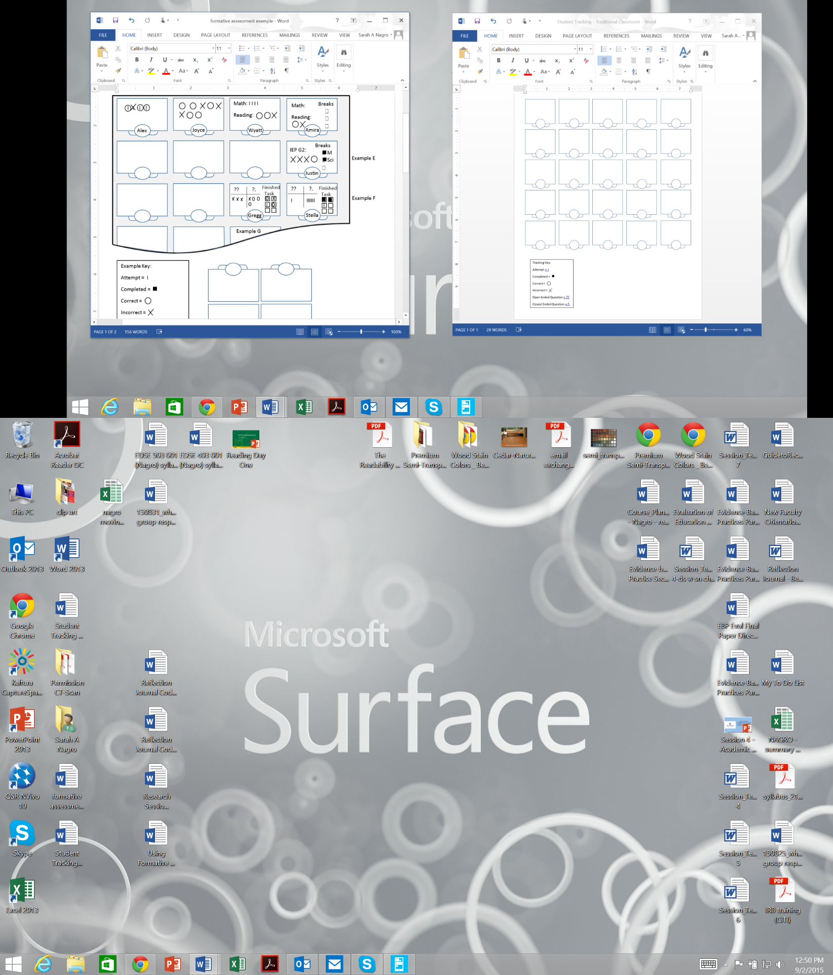

Examples:

Tracking Key:

Attempt = I

Completed = 

Correct =

Incorrect =

Open Ended Question = ??

Closed Ended Question = ?.